Case Study
Requirements met
- Runs on port 5000
- Simple in-memory store (no DB)
- Endpoints:
  - GET / → welcome message
  - GET /tasks → returns all tasks
  - POST /tasks → adds a new task
app.py
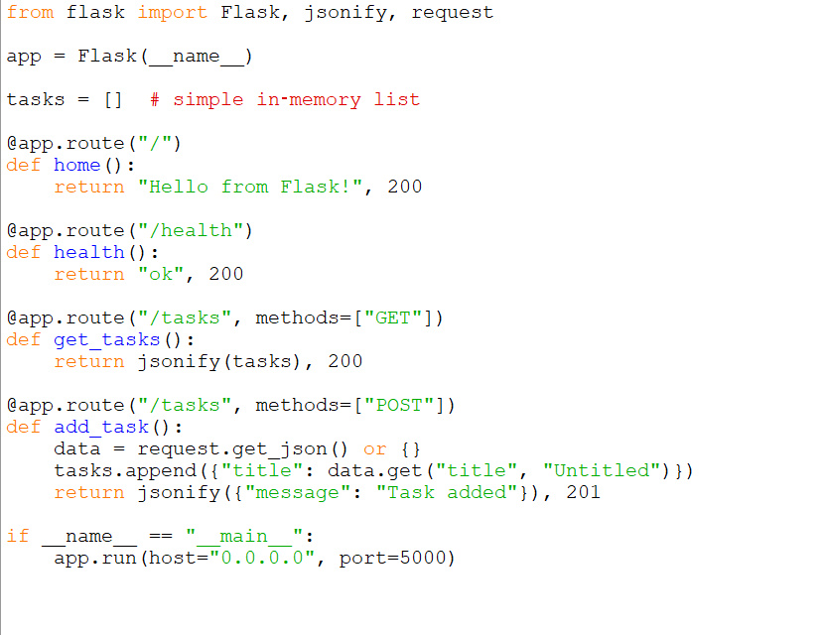
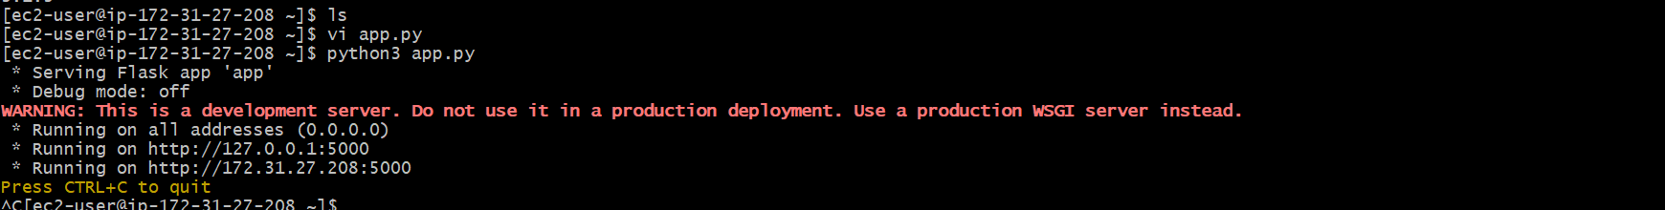
Installing the Docker and starting the docker service by using the below commands
sudo yum install -y docker
sudo systemctl start docker
sudo systemctl enable docker
sudo systemctl status docker
sudo usermod -aG docker ec2-user
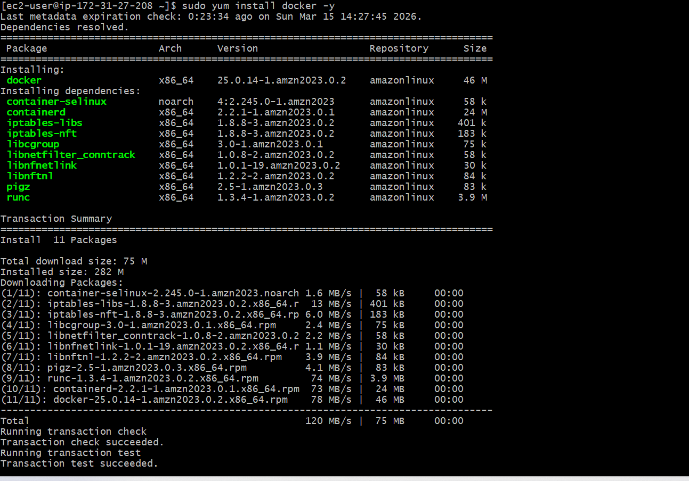
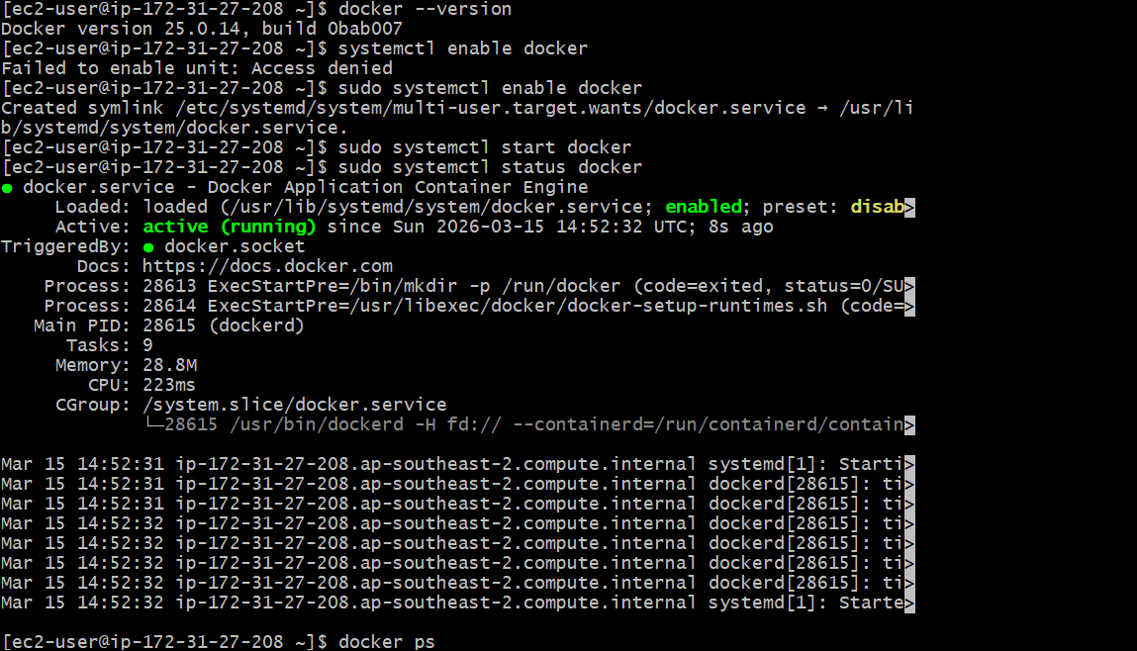
and then creating the docker file
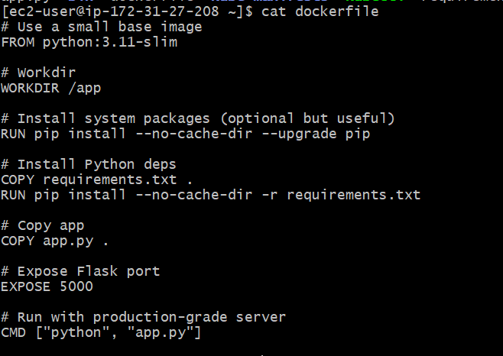
after creating the docker file we can build the docker image form docker file what we created along with requirements.txt file

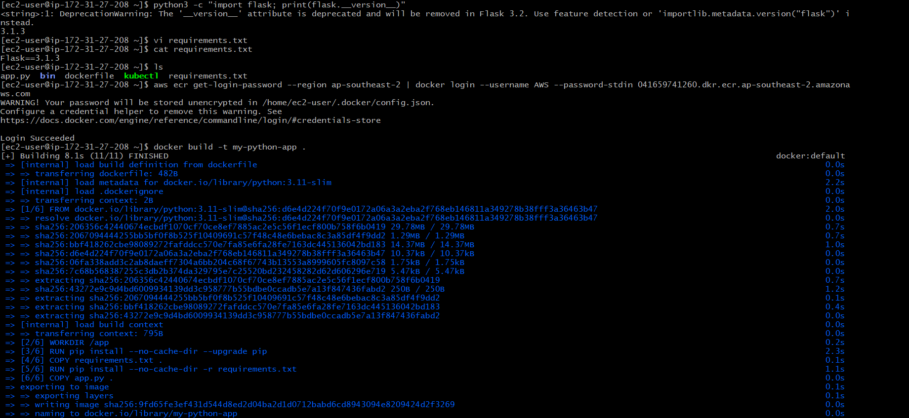
Then after we can create the ECR registry and we can push the docker image into registry by using the below commands
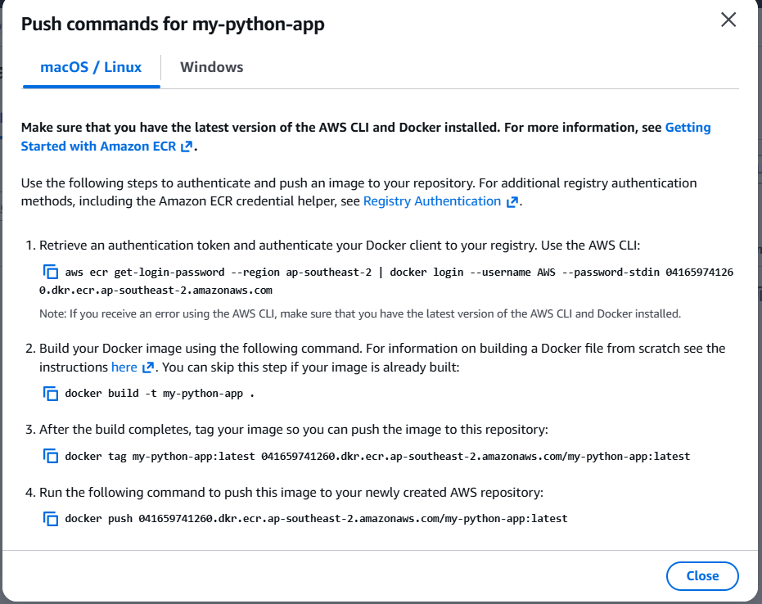
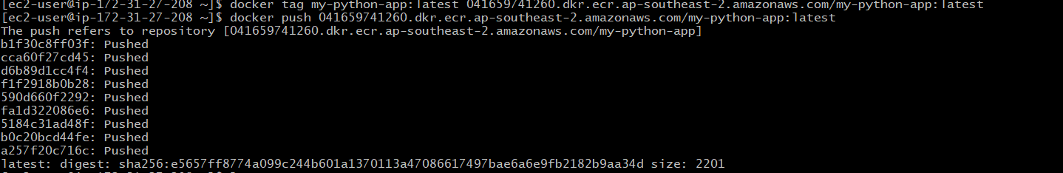
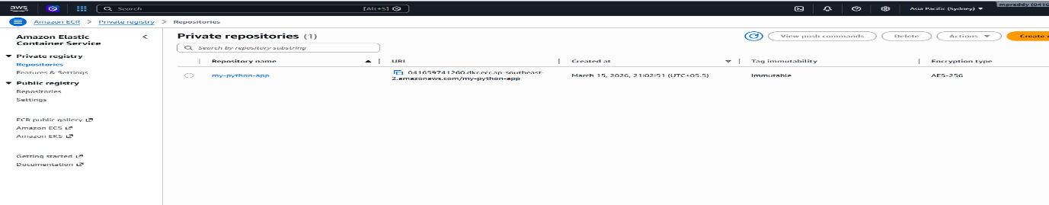
and then we can install the aws cli & configure the aws Access key & Secret access key:
And we can install the kubectl along with eksctl by using the below commands.
curl -LO https://s3.us-west-2.amazonaws.com/amazon-eks/1.35.2/2026-02-27/bin/linux/amd64/kubectl
chmod +x kubectl
mkdir -p $HOME/bin
cp kubectl $HOME/bin/kubectl
echo 'export PATH=$HOME/bin:$PATH' >> ~/.bashrc
export PATH=$HOME/bin:$PATH
kubectl version --client
curl -sLO "https://github.com/eksctl-io/eksctl/releases/latest/download/eksctl_Linux_amd64.tar.gz"
tar -xzf eksctl_Linux_amd64.tar.gz
sudo mv eksctl /usr/local/bin/
eksctl version
and then we can create the k8s cluster
# Create Cluster
eksctl create cluster --name=eksdemo \
--region=ap-southeast-2 \
--zones=ap-southeast-2a,ap-southeast-2b \
--without-nodegroup
# Get List of clusters
eksctl get cluster
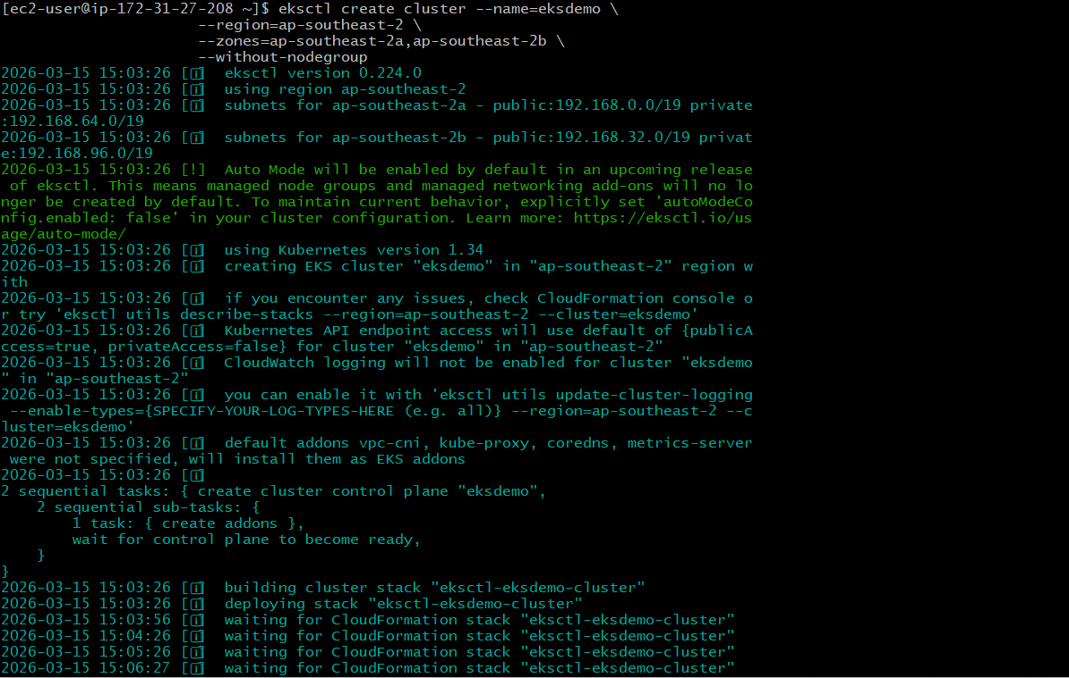
- Associate EKS Cluster to IAM OIDC Provider
- eksctl utils associate-iam-oidc-provider \
--region ap-southeast-2 \
--cluster eksdemo\
--approve
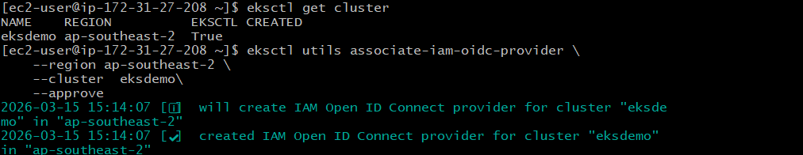
- Create EKS Node Groups
#Create EKS Node Group in Private Subnets
eksctl create nodegroup --cluster=eksdemo \
--region=ap-southeast-2 \
--name=eksdemo-ng-private1 \
--node-type=t3.small \
--nodes-min=2 \
--nodes-max=4 \
--node-volume-size=20 \
--ssh-access \
--ssh-public-key=K8S_Demo \
--managed \
--asg-access \
--external-dns-access \
--full-ecr-access \
--appmesh-access \
--alb-ingress-access \
--node-private-networking
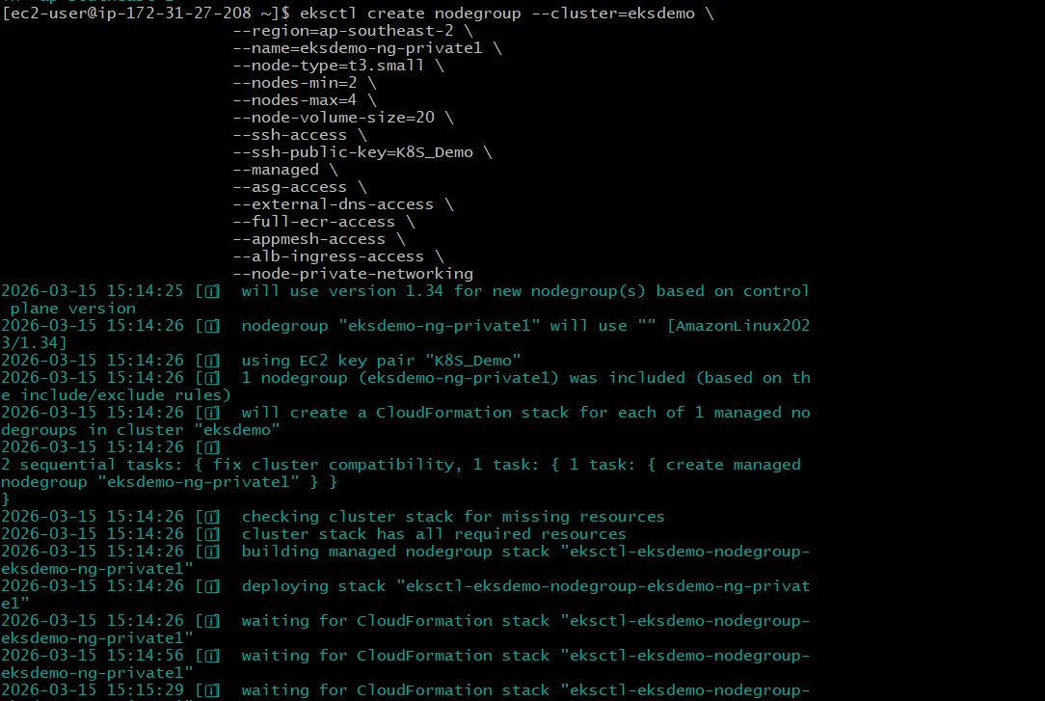
- Verify Cluster, Node Groups, services
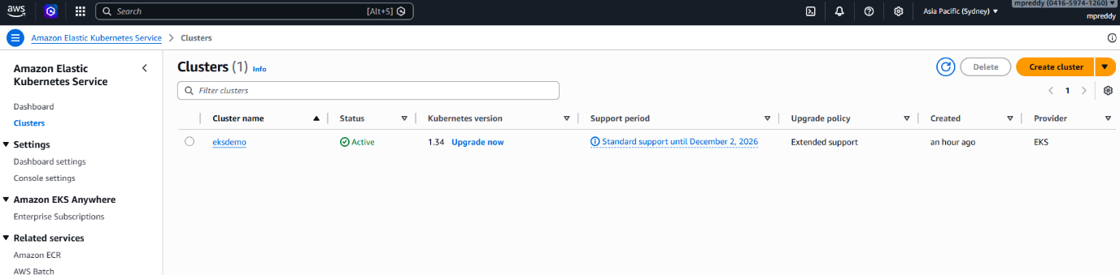
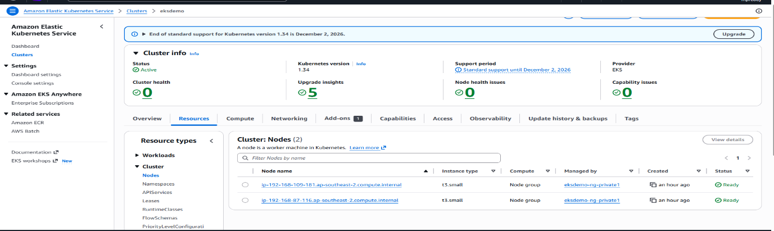
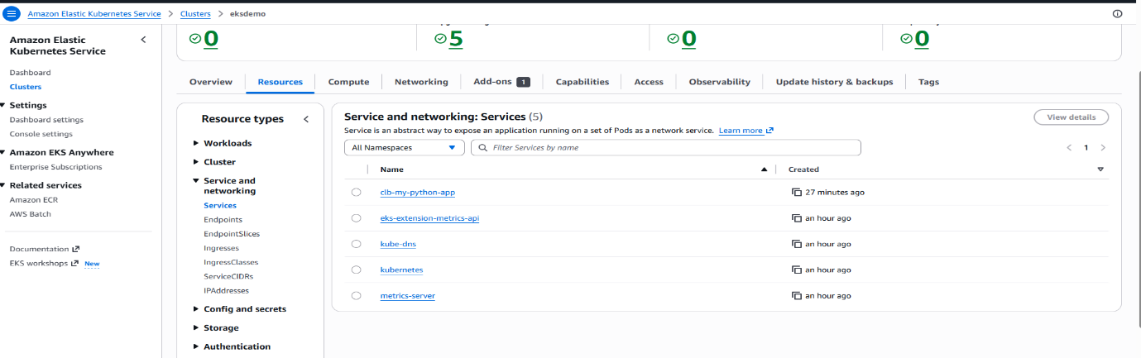

And check the vpc components like Nat gateway, public subnets, private subnets and route tables.
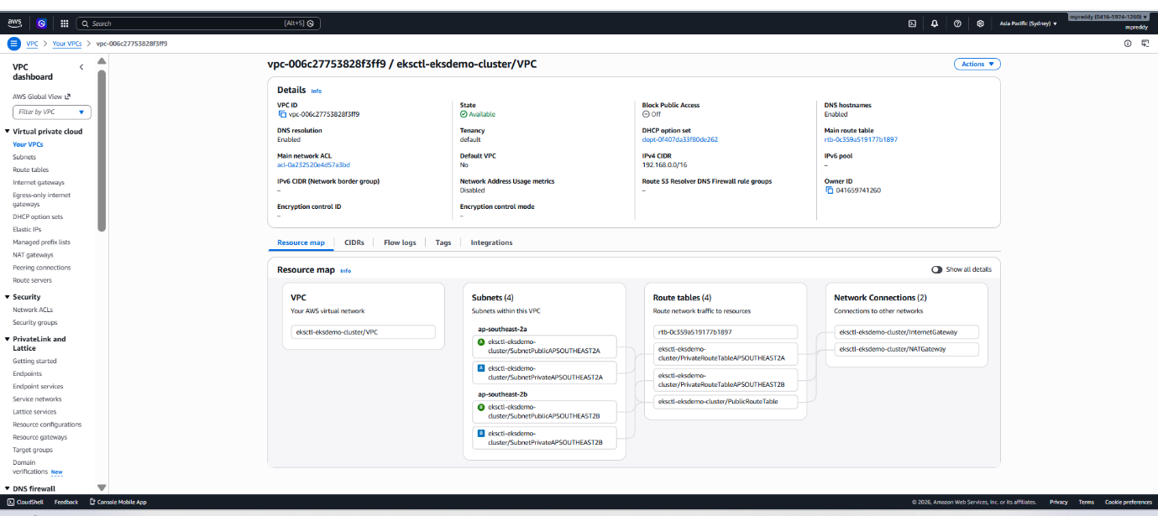

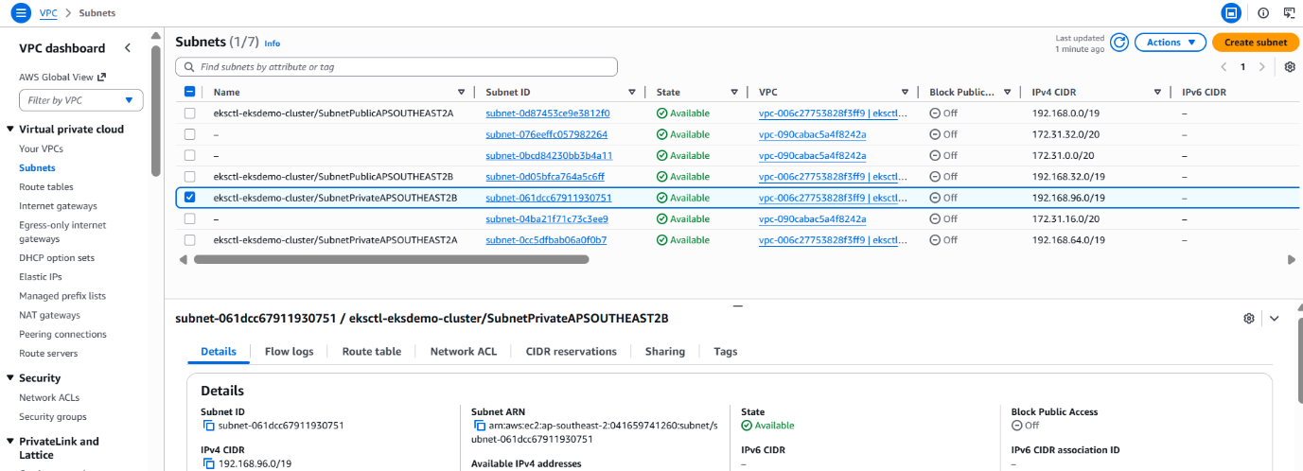

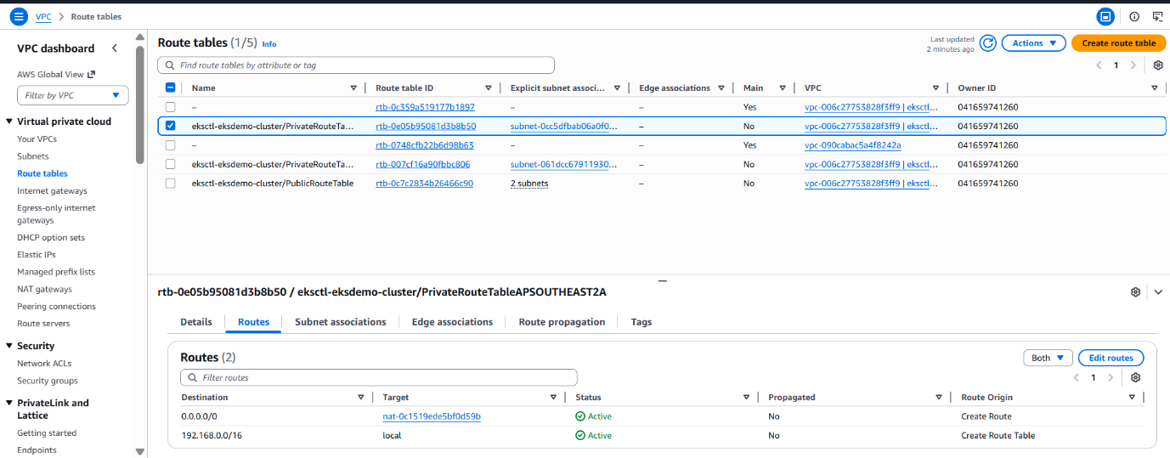
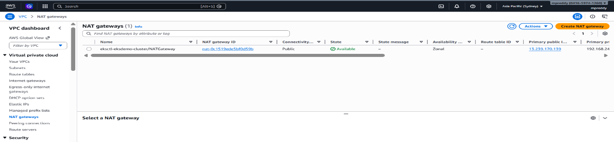

- Verify if new CLB got created
  - Go to Services -> EC2 -> Load Balancing -> Load Balancers
    - CLB should be created
    - Copy DNS Name (Example: xyz.elb.ap-southeast-2.amazonaws.com)
  - Go to Services -> EC2 -> Load Balancing -> Target Groups
    - Verify the health status, we should see active.

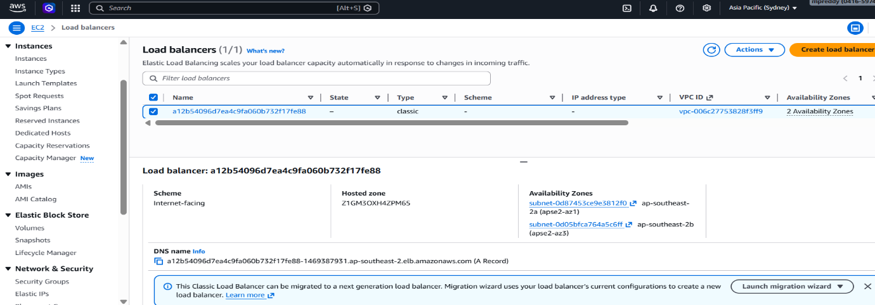
and after creating all the setup then we can start to write the kube-manifests files and execute by using the below commands
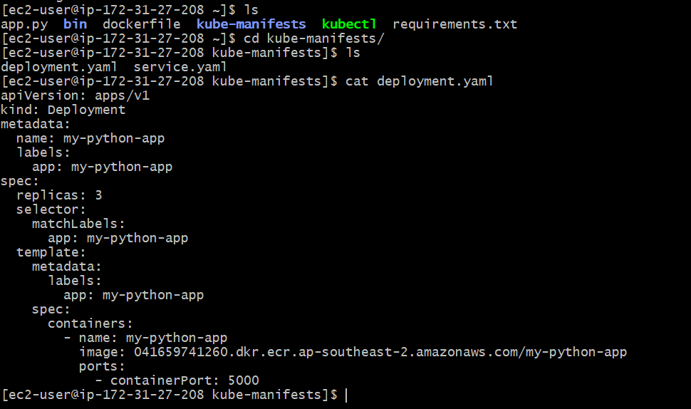
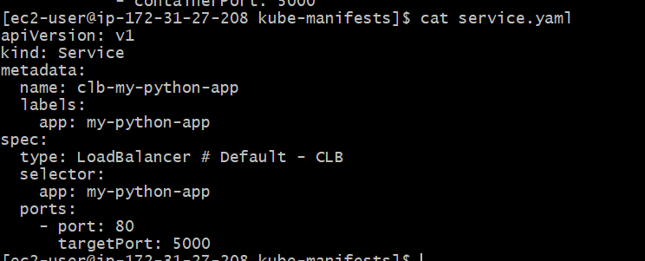
# Deploy all manifests
kubectl apply -f kube-manifests/
# List Services (Verify newly created CLB Service)
kubectl get svc
# Verify Pods
kubectl get pods -o wide
and then copy the DNS name and test it over the browser
